***Course Name: Virtualization and Cloud Computing***

***Assignment No: 02***

*1. Creating two container’s :*

*Container-1: ruhul*

$ sudo lxc-create –t download –n ruhul

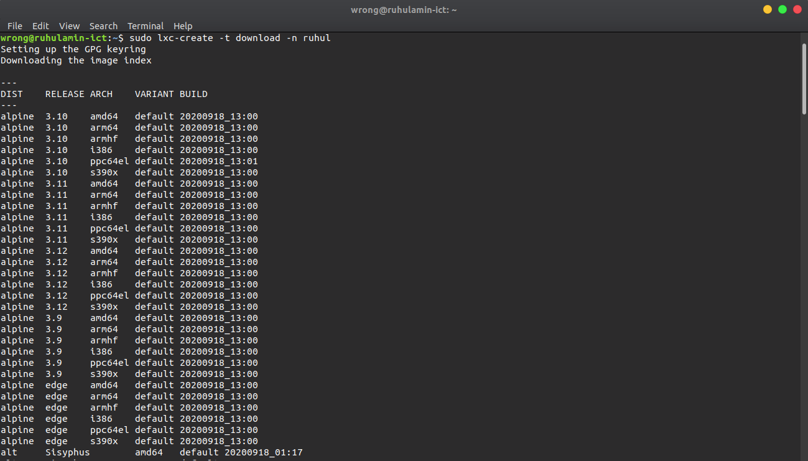

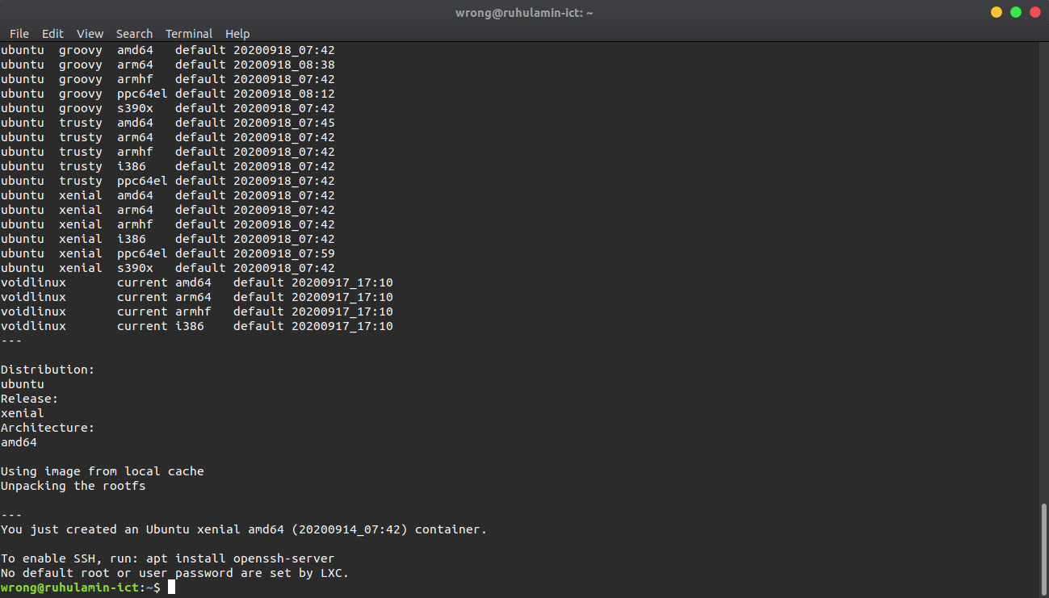

*Container-2: test*

$ sudo lxc-create –t download –n test

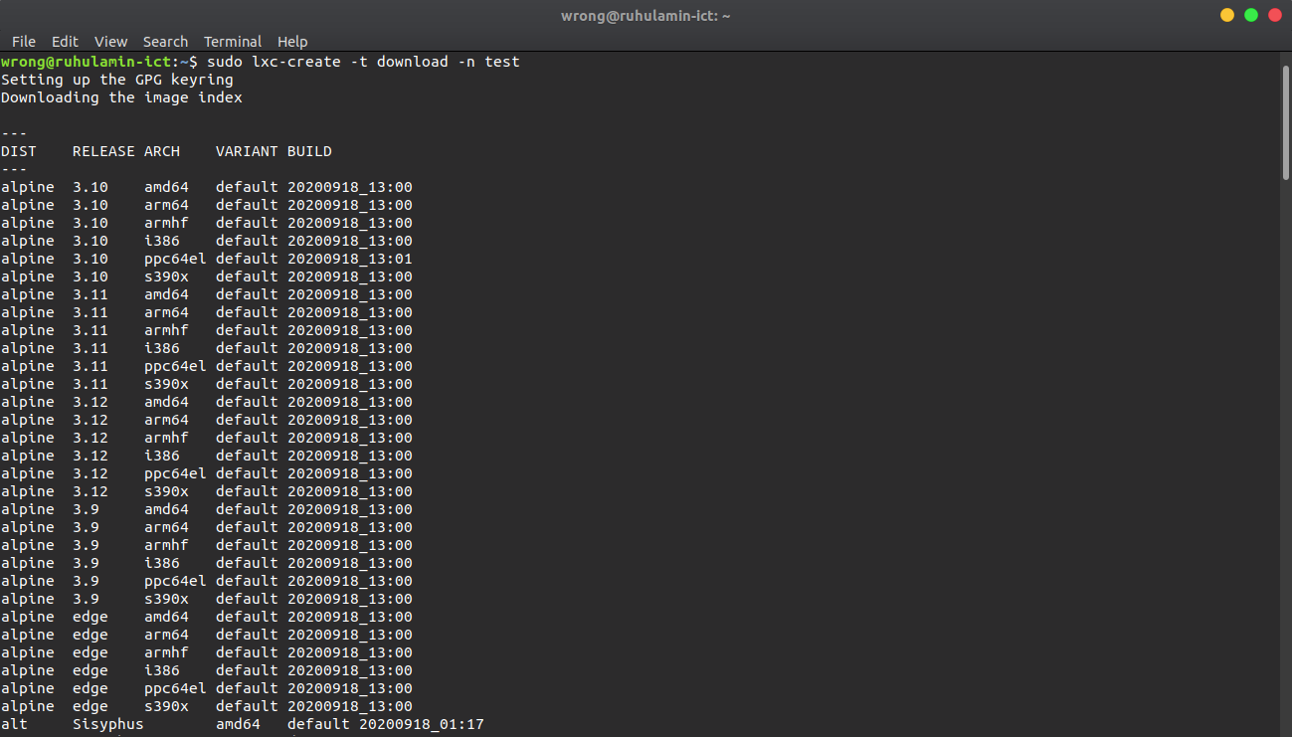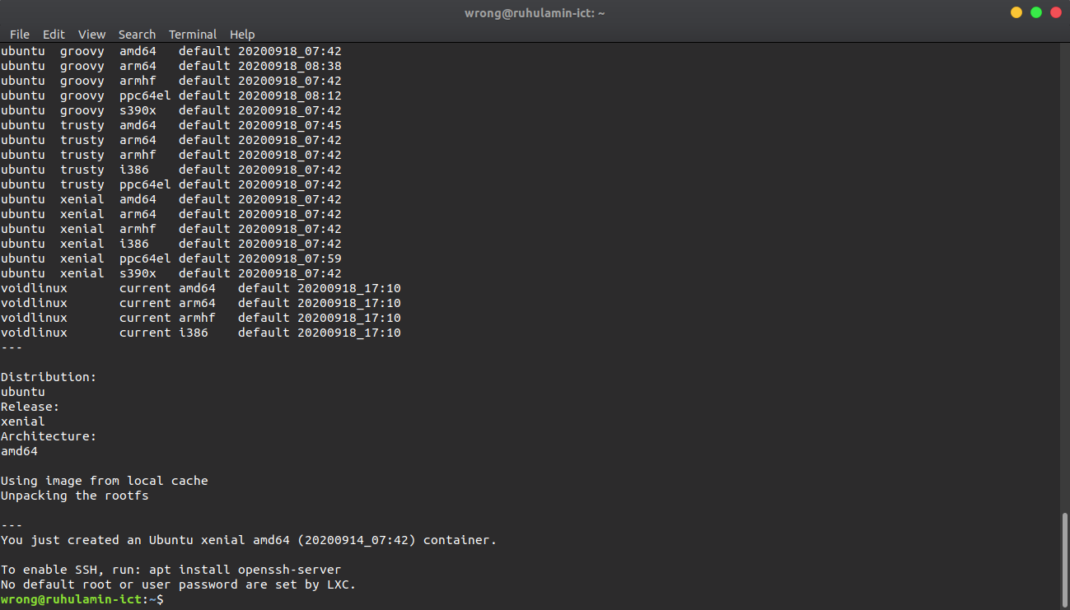

*Both of the containers are on running state.*

$ sudo lxc-ls –fancy

$ sudo lxc-start –n ruhul

$ sudo lxc-start –n test

$ sudo lxc-ls --fancy

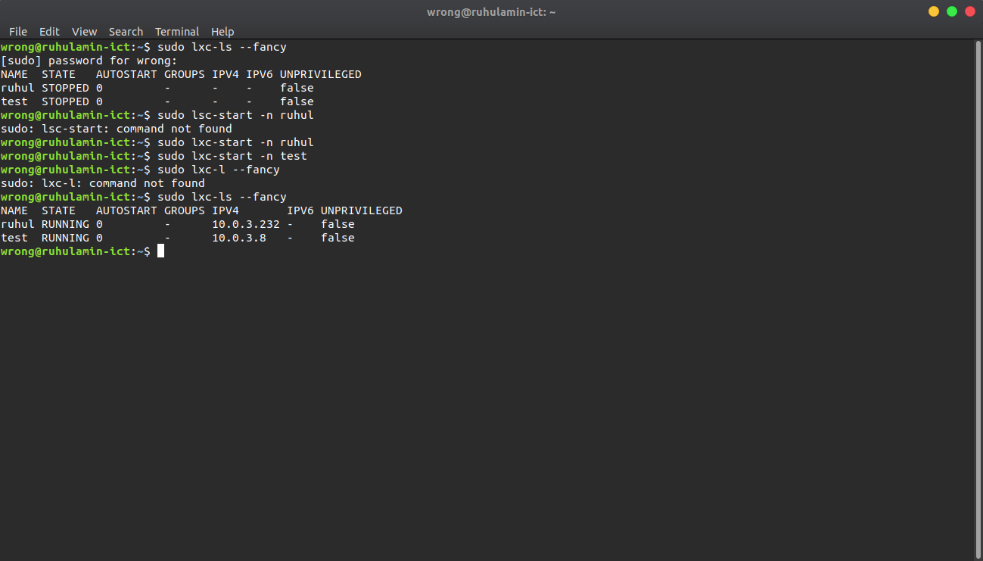

*2. Installing web server (apache) in container-1(ruhul):*

# apt-get install apache2

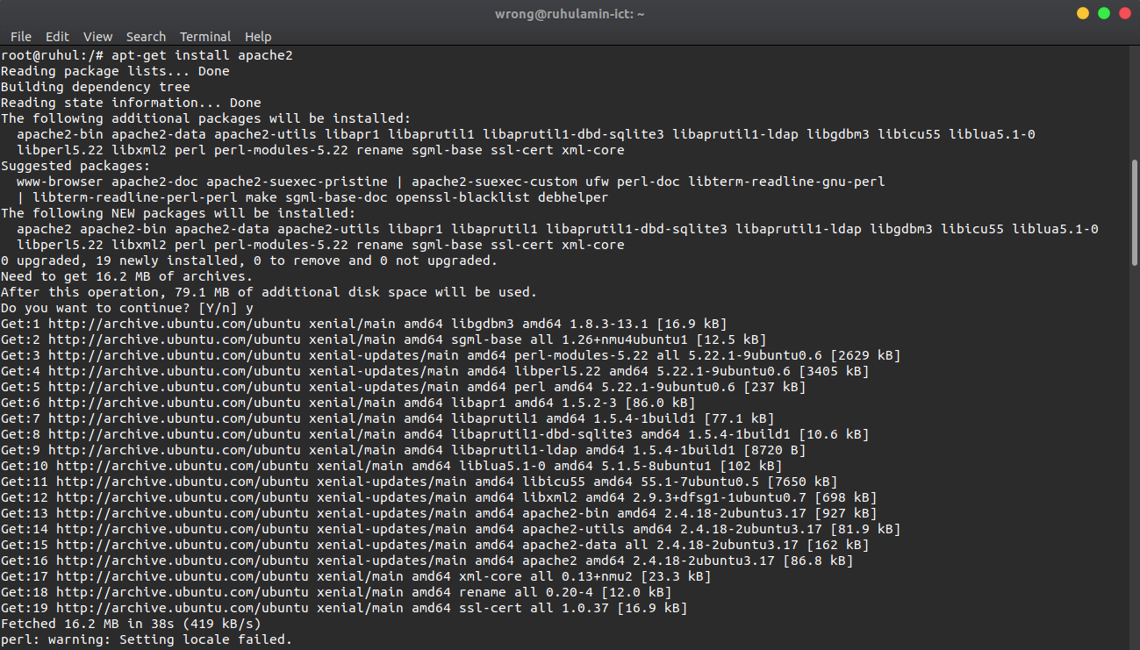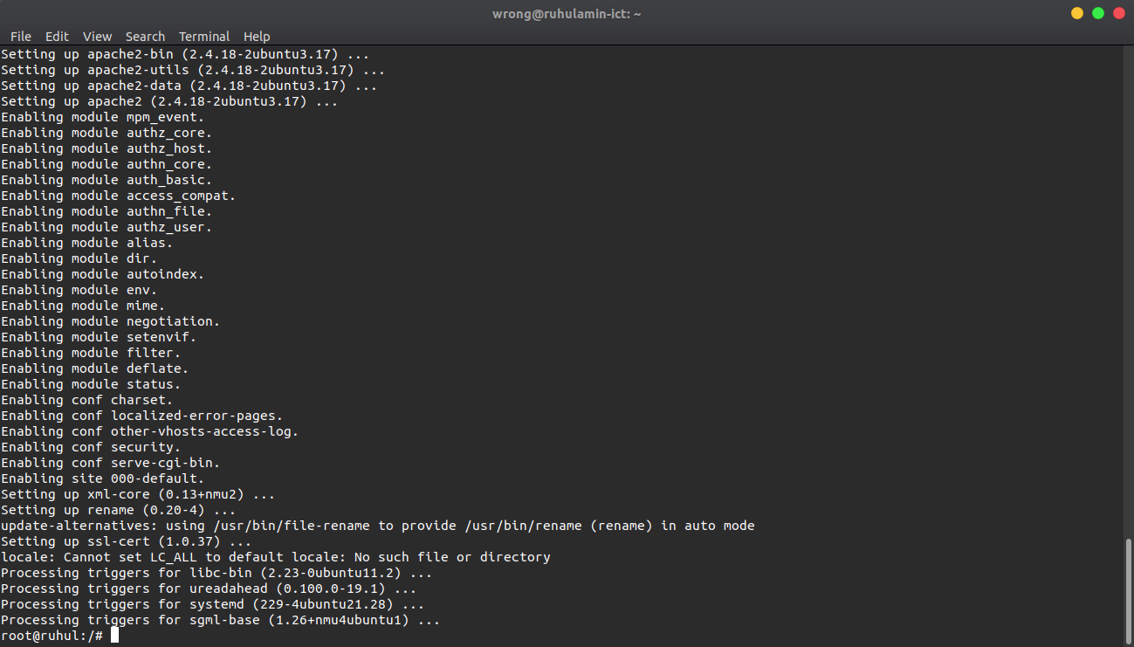

*Configuration of web server (apache):*

# apt-get install ufw

# ufw status

# ufw enable

# ufw app list

# ufw allow ‘apache’

# ufw status

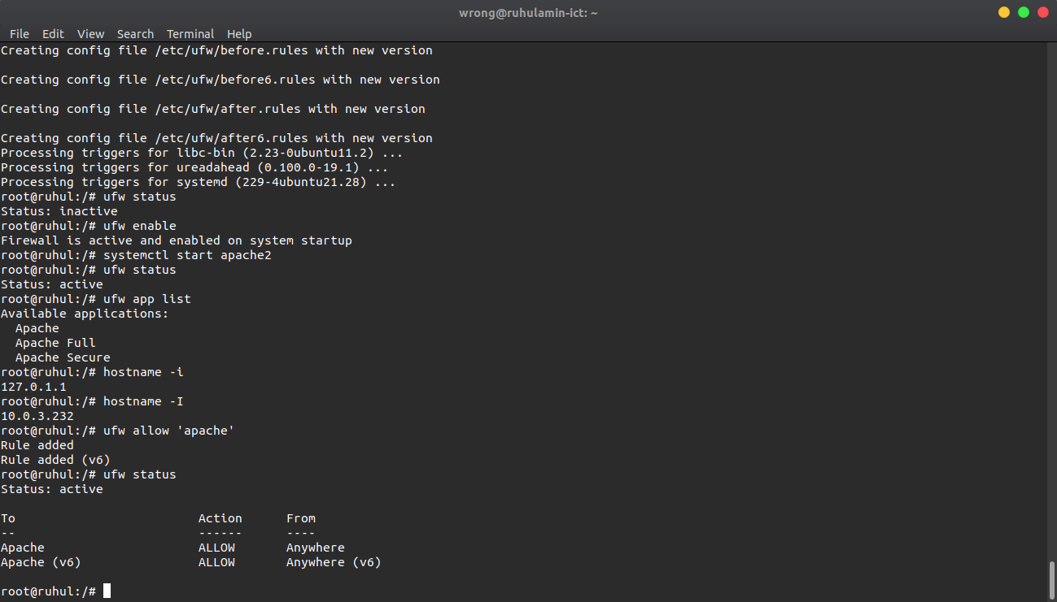

*3. Creating an html page containing following information:*

Name: Md. Ruhul Amin

Institute: Mawlana Bhashani Science and Technology University

Country: Bangladesh

E-mail: [hmruhul16.mbstu@gmail.com](mailto:hmruhul16.mbstu@gmail.com)

# cd /var/www/html

# apt-get install nano

# nano introduction.html

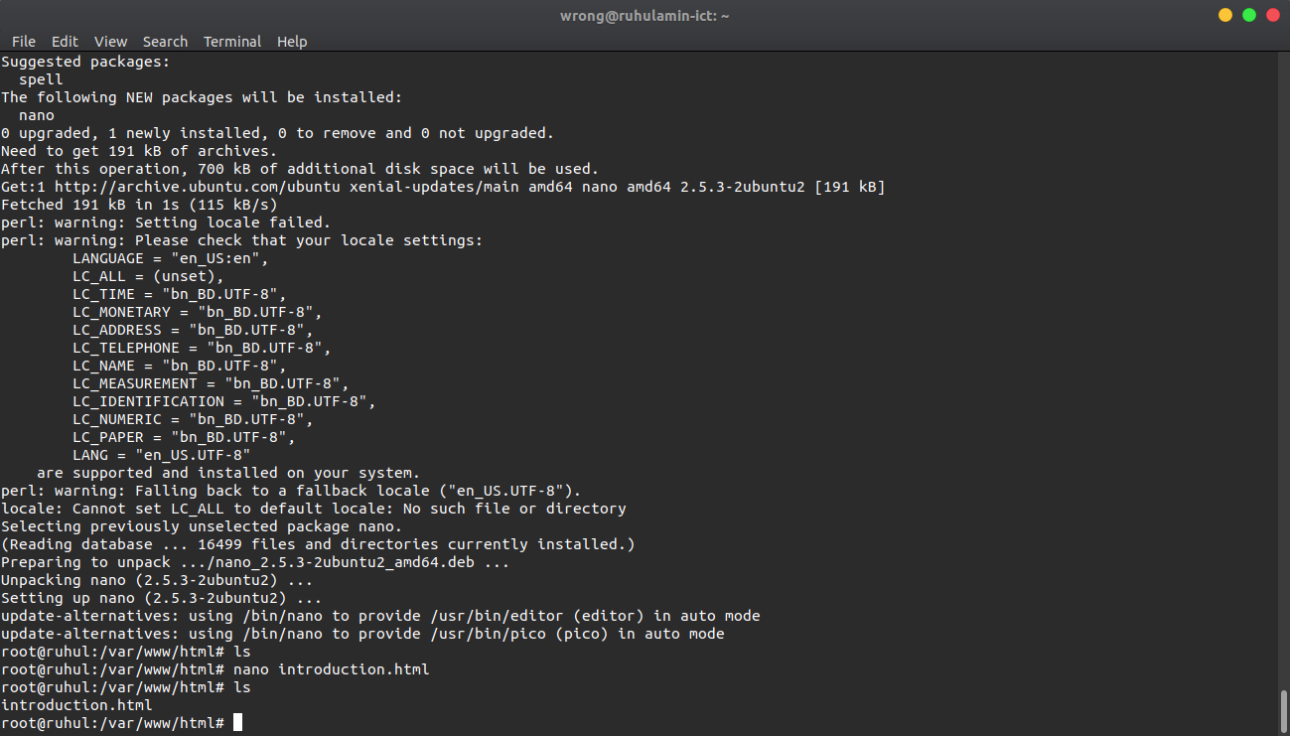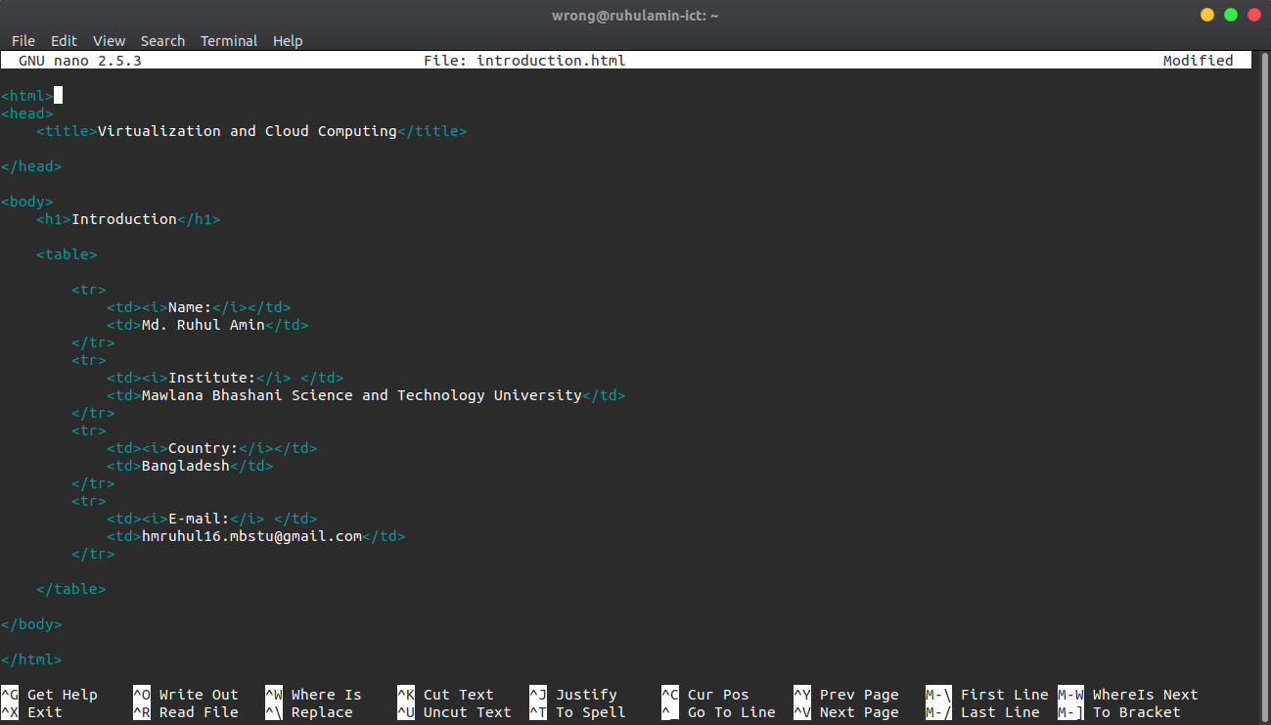

*4. Installing curl on container-2 (test) and browse container-1’s (ruhul) web page using container-1’s (ruhul) ip address :*

Current status of these two containers:

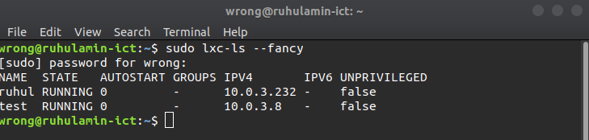

*Curl installing on conainer-2 ( test):*

# apt-get install curl

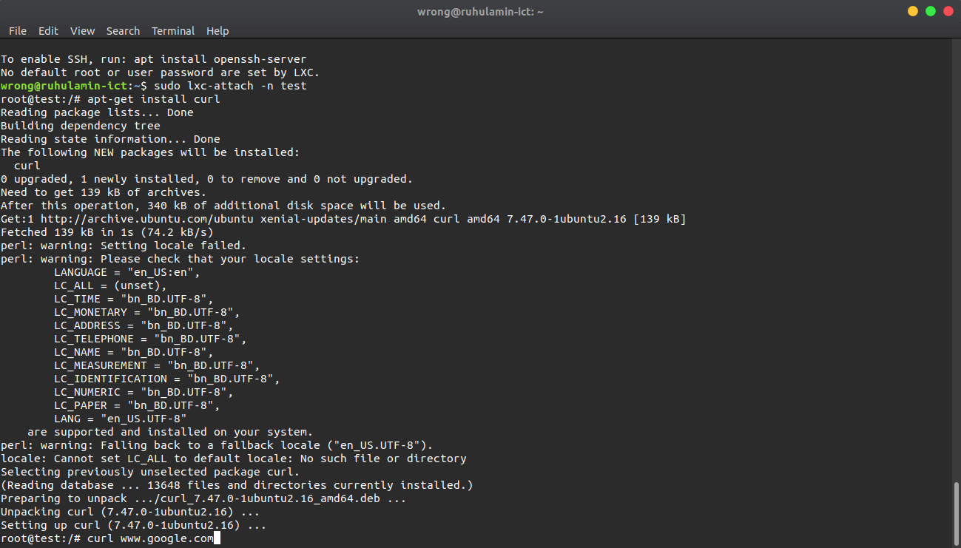

*Curl installed in container-2 (test):*

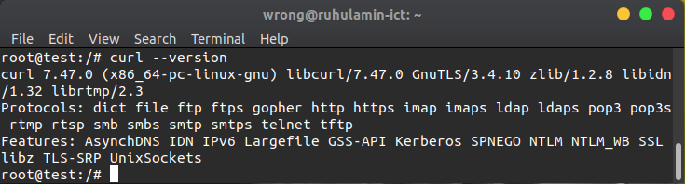

*Web server (apache) active in container-1 (ruhul):*

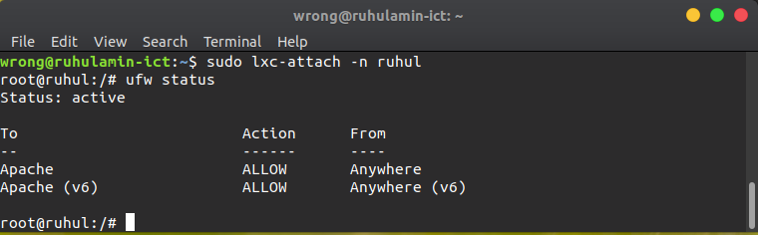

*Browse container-1’s ( ruhul ) web page through container-2 by using curl container-1’s ip address:*

# curl 10.0.3.232

